Online Safety Newsletter

December 2023

Get to know Age Ratings
Minecraft

Minecraft remains ever popular and with Christmas ahead of us, maybe your child will be receiving this game as one of their presents. Minecraft Legends is rated as PEGI 7 meaning it is suitable for those over 7 years of age. The App store rate Minecraft as 9+.

You should be aware that there is a multiplayer option so players can chat to each other, and in-app purchases are available. Parental controls are available, either within Minecraft or on the console itself e.g. Nintendo Switch or PlayStation. Find out more here:

https://www.minecraft.net/en-us/article/parental-controls

Age ratings are in place to help protect your child, so we thought we’d provide you with a little reminder of how important it is to check the age ratings of what your child is accessing online. Here are the age ratings of some of the more popular apps that young people are accessing. Did you know that WhatsApp has an age rating of 16?
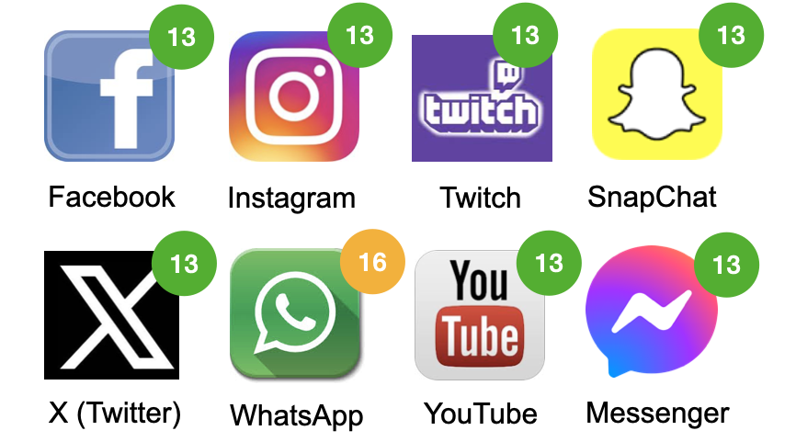

Whether your child is viewing films, accessing apps, playing games online, using social media or downloading other apps – check the age rating first to see if your child is old enough. In addition, the likes of PEGI include further content descriptors, which will give you an indication of the type of content that your child might view e.g. violence, if accessing the app/game etc.

Toxicity in game play

Safe In Our World and Ubisoft (creators of games such as Assassins Creed) have co-developed the ‘Good Game Playbook’. The playbook will be sent to players reporting disruptive behaviour as well as the individual reported. This is to support the person affected as well as to try and educate the person reported about the harm their behaviour might have on others.

You can read the handbook here:

https://safeinourworld.org/news/ubisoft-safe-in-our-world-partner-to-combat-in-game-toxicity/

It is important to note that whilst age ratings do allow you to see if something may be appropriate for your child, it is also important to review the content yourself. This will allow you to make an informed decision as to whether it is suitable for your child to access and if it would be beneficial to apply further parental controls.

Further information
Parent Zone have published this article about why age ratings matter:
https://parentzone.org.uk/article/age-ratings
Artificial Intelligence (AI)

It can be difficult to keep up to date with new technologies and to know if there are any related risks that we need to be aware of when using new technologies. AI is being talked about a lot, so it is worthwhile learning more about it now to help support/answer questions if our children show an interest. Twinkl provide a brilliant overview of AI here:

https://www.twinkl.co.uk/blog/parents-guide-top-tips-for-navigating-generative-ai-safely-with-kids

Users of this guide do so at their own discretion. No liability is entered into. Current as of the date released 1.12.23.

Fake Profiles and Cyberbullying

Setting up a profile impersonating somebody else with the intention of being unkind to others/to cause embarrassment to the individual is a form of cyberbullying.

If your child has set up a fake profile, talk to them about how this is a form of bullying and therefore not acceptable.

It is important that we talk to our children about the issue of cyberbullying and let them know that if they are ever a victim of it then it is not their fault, and they should tell you (or a trusted adult) straightaway. Talk to your child about reporting and blocking tools on social media or online games and show them how to use them to report any form of bullying.

You can read more about cyberbullying here:
- https://www.childline.org.uk/info-advice/bullying-abuse-safety/types-bullying/bullying-cyberbullying/
- https://www.nspcc.org.uk/what-is-child-abuse/types-of-abuse/bullying-and-cyberbullying/

Additionally, Report Harmful Content have listed how you can report impersonation accounts on the different social media networks here:
https://reportharmfulcontent.com/advice/impersonation/

Snapchat
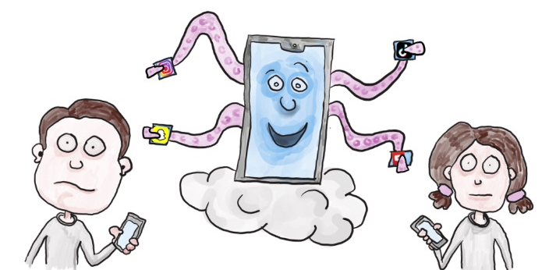
What is Snapchat?
Snapchat is a social media app used for messaging and sharing photos and videos. You must be 13+ to sign up. Users can send messages (snaps) to others that can only be seen for a set time e.g. 10 seconds and users can also upload snaps to stories, which disappear after 24 hours.

What should I be concerned about?
There are risks to using Snapchat, including the risk of your child viewing content that is not appropriate for them, location sharing and contact from strangers.

Family Centre features
Family Centre includes features such as allowing you to see who your child is friends with, who they are communicating with (not the contents of conversations though) and who your child has sent messages, photos or videos to in the last week. You will also be able to report any accounts that you are concerned about as well as restrict sensitive content. Snapchat have also published a safety checklist to help support conversations about how to use Snapchat safely:
- https://parents.snapchat.com/en-GB/parental-controls?lang=en-GB

New safeguarding features
Snapchat have recently announced their newest features to help protect 13-17-year-olds. The first feature is in-app warnings so a pop-up warning will now be displayed if someone tries to add them as a friend that they don't have mutual contacts with, or the person isn't in their contacts.

The second feature is ‘stronger friending protections.’ Currently 13-17-year-olds must have several mutual friends in common for that user to show up in search results or as a friend suggestion, but this number has been increased. These two features are available to users aged 13-17-year-olds, this is one of the reasons why it is always important for your child to sign up with their correct date of birth, so they can benefit from any such features.
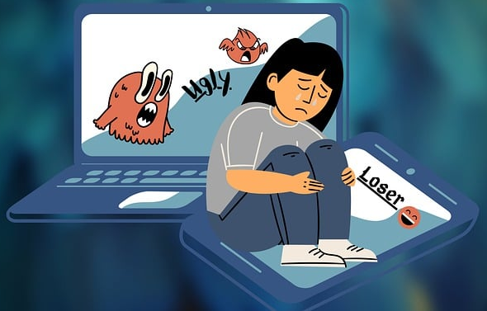
- https://values.snap.com/en-GB/news/new-safeguards-for-snapchatters-2023

Safety tips
Please make sure the appropriate privacy settings are set up on Snapchat and your child knows how to block and report other users if necessary:
- https://support.snapchat.com/en-GB/article/privacy-settings2

More information
- https://www.virginmedia.com/blog/parental-controls/snapchat

